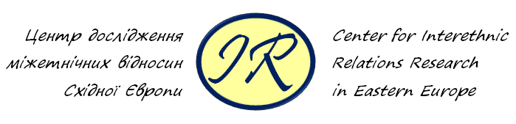

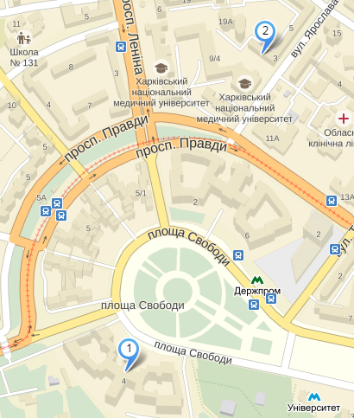

- Vasyl Karazin Kharkiv National University, 4 Svobody Sq.
- Hotel Voyage, str. Halana 3

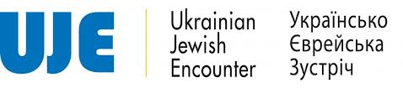

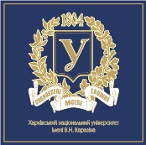
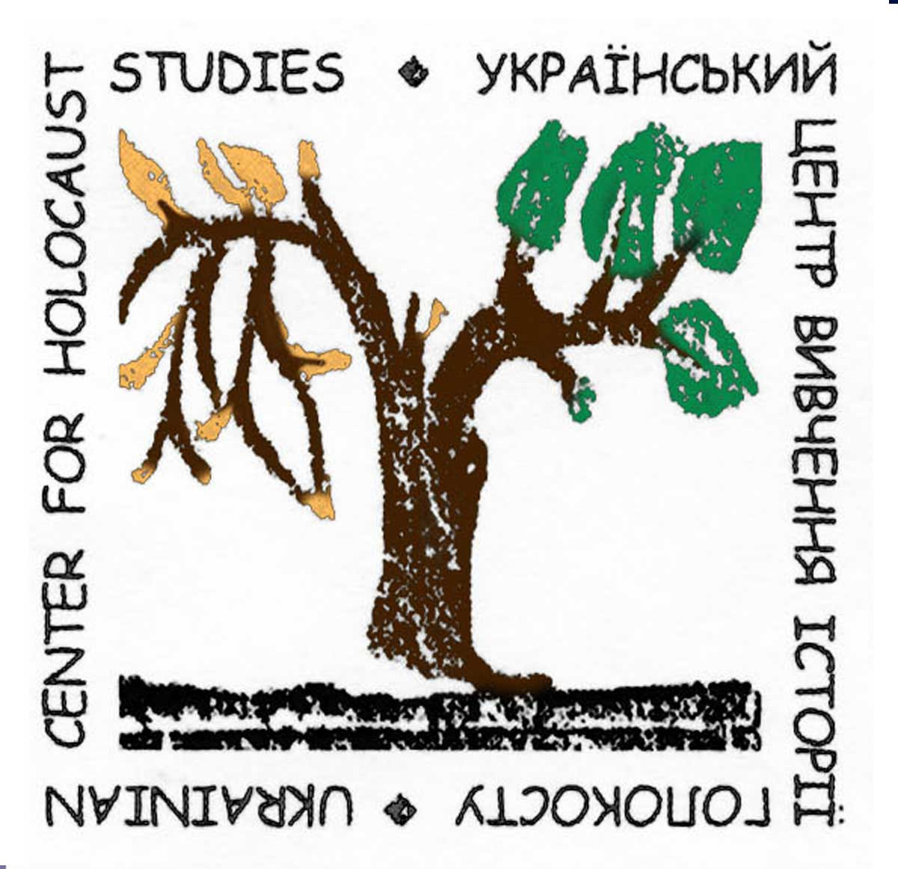
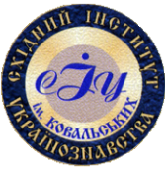

JEWS | in the Ethnic Mosaic of Eastern Europe

Conference Program

September 24 - 25, 2015
Kharkiv, Ukraine

Jews in the ethnic mosaic
of Eastern Europe
Thursday, September 24
10.00 - 11.00 | Welcome speech: Yuri Radchenko
Keynote:
Arkadi Zeltser Memory in the Monuments: Jewish Soviet Identity and the Holocaust
Anatoly Podolsky The Politics of Memorialization regarding the Holocaust victims in Ukraine (new memorials in Western Ukraine case)

11.00 - 11.20 | Coffee Break
11.30 - 13.20 | Panel І Researches on Jewish history  Moderator: Andriy Domanovsky (Kharkiv)  Anna Maria Basauri Zyuzina (Kyiv) Researches on Judaism in Soviet Ukraine (1957-1985): T. Kychko, A. Edelman and I. Myhovych  Ihor Dvorkin (Kharkiv) Jews of Naddnipranshchyna in the Late XVIII - Early XX Century in Historiography  Marina Strilchuk (Dnipropetrovsk) History of the Jews in the first Half of the Twentieth Century: Images in the Post-Soviet Ukrainian Historiography  Expert’s comment: Anatoly Podolsky (Kyiv)
13.30 - 14.20 | Lunch
14.30 - 17.00 | Panel ІІ Challenges and Transformations  Moderator: Yevgen Kotliar (Kharkiv)  Anna Varanytsya (Lviv) Primary Education as a Factor of (non)Preservation of National Identity: Discussion and Practice in the Jewish Community of Galicia in the Second Half of XIX - early XX Century  Adam Raszewski (Warszawa) Jewish Identity vs Multinational Monarchy in Joseph Roth Writings  Ilya Yuzefovіch (Moscow) Strategy of "Jewish accent" Formation in Russian Literature. Base on Writings XIX-XX Centuries  Eugeniy Monastyrsky (Lviv) Jewish Factor in the Formation of the Soviet Agitation and Propaganda Among National Minorities (1919 - 1924)  Expert’s comments: Yaroslav Hrytsak (Lviv), Grzegorz Krzywiec (Warsaw)
17.00 - 17.20 | Coffee Break
17.30 - | Public lecture:  Marco Carynnyk (Toronto) Arkady Lubchenco: Epoch, Life, Diary, Thirst  Moderator: Volodymyr Sklyar (Kharkiv)

Friday, September 25
9.30 - 11.00 | Panel ІІІ Jews and the surrounding community in urban space  Moderator: Pavlo Yeremeyev (Kharkiv)  Andrey Shpirt (Moscow) City , Church, Jewish Community and the Religious Forms of Violence: a Dispute over Church Land in Brest, 1669-1671  Artem Kharchenko (Kharkiv) From Shtetl to the Metropolis: Kharkiv as the Center of Jewish Internal Migration in the Russian Empire  Larissa Karachevtseva (Kyiv) Urban Memory Maps as Object of Interdisciplinary Research  Expert’s comments: Yaroslav Hrytsak (Lviv), Grzegorz Krzywiec (Warsaw)
11.00 - 11.20 | Coffee Break
11.30 - 13.30 | Panel IV Ukrainian contexts of the Holocaust  Moderator: Denys Zhuravliov (Kharkiv)  Yuri Radchenko (Kharkiv) OUN (m) and the Holocaust: Ivan Yuryev Case Study  Roman Mykhalchuk (Rivno) Rivne Legal Press as a Means of Anti-Semitic Propaganda: Comparative Analysis and Dynamics of Publications  Anna Wylegala (Warsaw) 'What About This Jewish Stuff?' Jewish Property in Galicia During the World War II "  Expert’s comments: Arkadi Zeltzer (Jerusalem), Maris Ruks (Riga)
13.40 - 14.30 | Lunch
14.40 - 17.00 | Panel V Memory and myths in the totalitarian society  Moderator: Volodymyr Sklyar (Kharkiv)  Mychailo Martynenko (Lviv) Publicistics of Vladimir Belyaev in the Context of Memory of the Holocaust in Lviv, 1944-1948  Anna Medvedovska (Dniproperovsk) Reception of the Holocaust Late Soviet Union Public Opinion (1950s-1980s)  Kateryna Yeremeyeva (Kharkiv) Representation of National Minorities and the Ukrainians in Institutionalized Humorous Discourse in the Soviet Ukraine  Mariya Vyatchina (Kazan) From "White Jews of Heisenberg" to Latgale "White Jews": Concepts of Etymology and Contextual Analysis  Expert’s comment: Arkadi Zeltzer (Jerusalem), Maris Ruks (Riga)

